**Report on general government budget**

**APRIL 2020**

General government budget recorded a **deficit of RON 26.82 billion (2.48% of GDP)** in the first four months of 2020, half of this amount corresponds to fiscal facilities adopted by the Government in order to mitigate the negative effects of the Covid-19 outbreak, i.e. supporting the liquidity of private companies (Annexes 1 and 2).

A larger deficit compared to the same period of last year mainly reflects the unfavourable dynamics of total revenues in March and April, as a consequence of payment deferral during the state of emergency (RON 11.1 billion)[1], as well as higher VAT reimbursements (RON + 3.11 billion) to support private companies’ liquidity. However, total revenues returned to an ascending path in April.

Also, on the expenditure side, beside the increase in expenditure as a result of applying current legislation, investment increased by RON 3.15 billion compared to the same period of last year, and exceptional payments related to Covid-19 pandemic totalled RON ~1.2 billion.

1. **general government revenue**

Total revenue amounted to RON 98.21 billion in the first four months, down by 1.3% compared to the same period of last year, largely reflecting a sizeable contraction in March (-25,1% YoY), as a consequence of fiscal facilities granted to support the economic activity during the state of emergency. In April, total revenue increased by RON 1.16 billion (+4,7% YoY), backed by the evolution of tax revenues (CIT, PIT, excise duties) and EU refunds.

***Personal income tax*** receipts totalled RON 7.85 billion in the first four months of 2020, up by 7.9% (yoy). This dynamics was backed by a 0.5% increase of total number of employees and a 8.5% increase of the average gross wage during Dec ′19-Feb ′20 compared to the same period a year ago.

The most important category – labour income tax receipts increased by 3.1% in the first four months. After a significant advance in Jan-Feb, one notes a deceleration in March-April as a consequence of payment deferral during the state of emergency and a deceleration of average gross earnings to 6.7% in March.

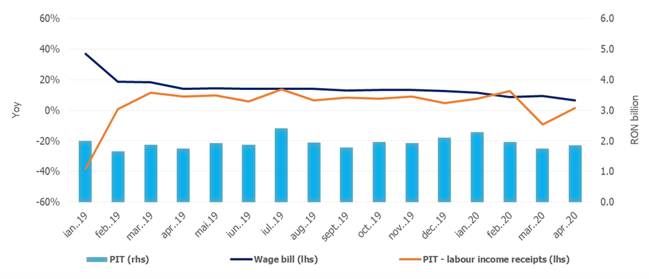

Source: MoPF, NIS, own calculations

**Fig.1 Personal Income Tax Revenue**

***Social contribution*** revenuetotalledRON 36.24 billion in the first four months, advancing by 1.1% compared to the similar period of last year. Similar to PIT dynamics, social contribution revenues were negatively influenced by the wage bill deceleration. Also, compared to the same period of last year, social contributions revenues were adversely affected by: (i) the change in the calculation basis of social security contribution (CAS) and health insurance contribution (CASS) due by part-time employees, and (ii) the extension from March 15th to May 25th of the submission deadline of the Single Fiscal form for individuals with independent activities.

The extension of the submission deadline determined a reduction of social contribution revenue in April (-1.7%, yoy), receipts being RON 1.46 billion lower than the tax obligation declared by taxpayers.

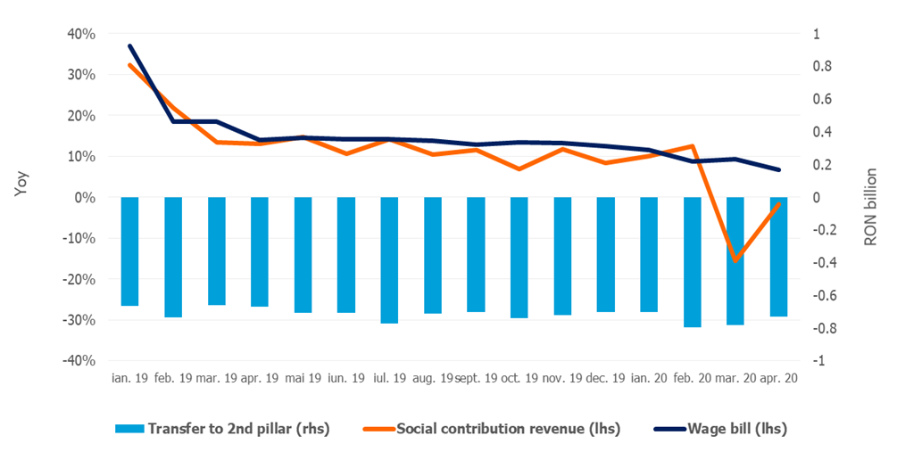

Source: MoPF, NIS, own calculations

**Fig.2 Social contribution revenue**

***Corporate income tax*** revenue amounted to RON 6.46 billion in the first four months, down by 8.2% (RON –0.57 billion) compared to the same period of 2019. This evolution is mainly explained by payment deferral in March (GEO no. 29/2020), as well as discounts offered to CIT taxpayers who pay the tax owed for 2020 Q1: 5% for large taxpayers and 10% for small and medium taxpayers (GEO no. 33/2020, total impact of RON 219 million). However, offering discounts led to a positive dynamics of CIT revenue in April (+27.6%, yoy).

***VAT*** receipts amounted to RON 15.94 billion in the first four months, down by 18.8% compared to the corresponding period of last year.

Over the first four months, the VAT revenues dynamics was negatively influenced by: (i) higher VAT reimbursement by 51.7% (yoy), a record level being reached in March in order to provide additional liquidity to private companies during the state of emergency, (ii) tax deferral in March and April, (iii) unfavourable evolution of economic activity since March, as a consequence of the state of emergency (mainly retail, services and manufacturing).

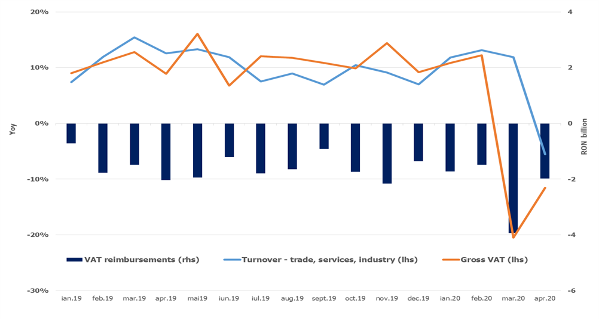

Source: MoPF, NIS, own calculations

**Fig.3 VAT revenue**

***Excise duties*** receipts totalled RON 10.15 billion in the first four months of 2020, advancing by 12.5% compared to the corresponding period of 2019.

In the first four months, excise revenue from energy products decreased by 9.6% (yoy), mainly due to a contraction of revenue in March (-10.9%, yoy) and April (-36.6%, yoy), otherwise expected in the context of the state of emergency. Excise revenue from tobacco products grew by 40.34% in the first four months, supported by a 4.2% hike in the excise level for cigarettes.

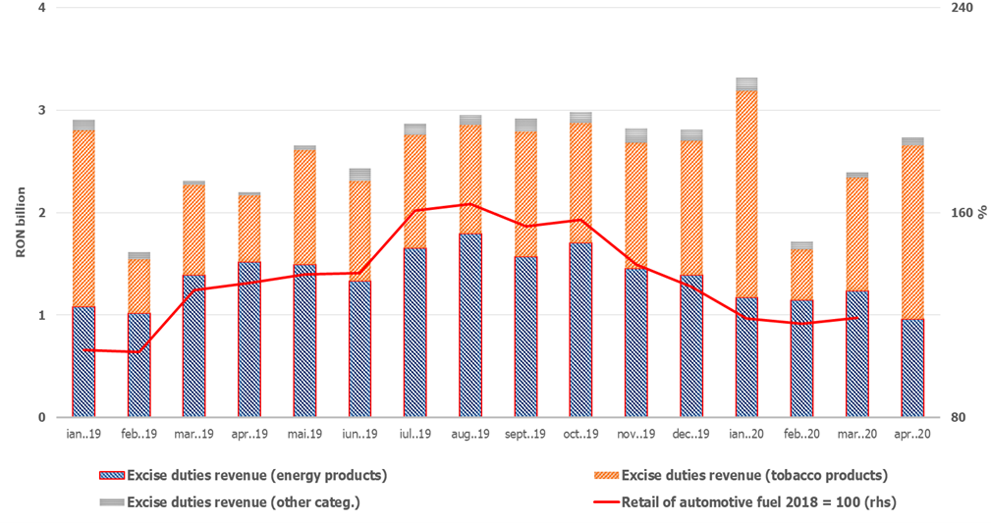

Source: MoPF, NIS, own calculation

**Fig.4 Excise duties revenue**

Revenue from ***taxes on use of goods*** totalled RON 1.97 billion, advancing by 50.6% compared to the similar period of 2019, mainly backed by revenue collected from broadcast licenses renewal (GD no. 226/2020).

***Non-tax revenues*** amounted to RON 7.36 billion in the first four months, up by 7.0% (yoy). Nevertheless, the positive dynamics of non-tax revenues was tamed by lower revenues in April[2].

***EU refunds and donations*** totalled RON 5.9 billion in the first four months of the year, up by 15.2% compared to the corresponding period of 2019.

1. **GENERAL GOVERNMENT EXPENDITURE**

General government expenditure totalled RON 125.03 billion, up by 12.7% compared to the same period of last year. As a percentage of GDP, total expenditure increased by 1.1 pp (from 10.5% of GDP to 11.6% of GDP). This increase is explained, on the one hand, by the measures adopted by the Government to limit the spread of the virus, and on the other hand by discretionary measures adopted in order to mitigate the negative impact on the economic activity.

Therefore, only in April, there were paid RON 312.0 million for technical unemployment benefits, RON 95.9 million for other categories of professionals and for those with an individual employment agreement that were forced to stop their activity in the context of the state of emergency, and RON 0.2 million for allowances paid to parents to supervise their children when educational institutions are temporary closed.

***Compensation of employees*** totalled RON 35.07 billion, up by 6% compared to the same period of last year, reflecting public wage hikes and introduction of meal allowance to all public employees as of January 1st, 2019 (Law 153/2017), but also by another round of public wages hikes as of January 1st, 2020.

As a percentage of GDP, compensation of employees amounted to 3.2%, increasing only marginally compared to the same period of last year (+0.1 pp). In April, compensation of employees totalled RON 8.85 billion, a lower amount compared to previous months.

***Goods and services expenditure*** expanded by 19.5% compared to the similar period of last year (RON 16.70 billion). A larger increase was recorded at local budgets level (22,9%), as well as for some public institutions entirely or partially self-financed (22,5%), mainly due to additional payments for drugs, sanitary materials and other products needed to test and to treat the people infected with Coronavirus.

Furthermore, compared to the similar period of last year, a 14.8% increase was recorded at the level of the Unique National Fund of Health Insurances due to higher payments for drugs and outpatient medical services reimbursements.

***Social assistance expenditure*** reached RON 43.72 billion, up by 17.2% compared to the similar period of last year. This dynamics is mainly explained by the increase of the pension point by 15% as of September 1st, 2019 (from RON 1,100 to RON 1,265); the increase of the social allowance for pensioners by 10%; of child allowance as of May 1st, 2019, as well as indexing child allowance with the 2019 inflation rate, as of January 1st, 2020.

At the same time, since April, payments have been made to offset the negative impact of the Coronavirus outbreak: temporary unemployment benefits (RON 312 million) and unemployment benefits for other categories of professionals and for those with an individual employment agreement that were forced to stop their activity due to the pandemic (RON 95.9 million). Furthermore, the sick leave reimbursements continue to be repaid at an accelerated pace (RON 365.9 million in April), in order to reduce the stock of outstanding payments.

***Subsidies*** reached RON RON 3.0 billion, the largest part being allocated to the agricultural sector, i.e. advance payments for the transitional national aid in the vegetal and zootechnical sector.

***Other expenditure*** amounted to RON 1.91 billion, representing mainly amounts related to payment titles issued by the National Authority for Properties Restitution, scholarships for students and payments related to court decisions, as well as allowances paid to parents to supervise their children when educational institutions are temporary closed (RON 0.2 million).

***Expenditure for projects financed from non-reimbursable external funds*** (including EU subsidies for agriculture) reached RON 6.91 billion, up by 20.5% compared to the corresponding period of last year.

***Investment***, which includes capital expenditure and spending related to development programs financed from domestic and external sources, amounted to RON 9.96 billion, up by 46.3% compared to the similar period of last year (reflecting increases at both central and local level, financed from both domestic and non-reimbursable external funds).

Furthermore, RON 191.9 million were paid from the budget of the Ministry of Internal Affair for the purchase of emergency medical products, including thermal scanners, in order to limit the spread of the Coronavirus.

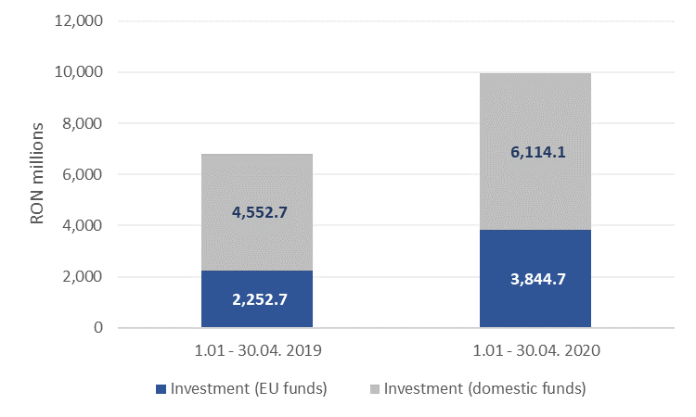

Source: MoPF

**Fig. 5 Public investment structure**









1. Fiscal facility granted through GEO no. 29/2020 regarding certain economic and fiscal measures to support private companies. According to GEO no. 29/2020, no late payment interest and penalties shall be owed for the tax liabilities outstanding as of March 21st, 2020 and not paid within 30 days as of the termination of the state of emergency.
2. GEO no. 34/2020 states that the validity of documents issued by public authorities which expire during the state of emergency is maintained. This measure generates reduction for a range of revenues from different public services, fees for issuing documents, etc.